Lab-2

// 1. Array Input & Output**

// * Take `n` elements from the user and display them.

#include<iostream>
using namespace std;

int main(){
int n;
cout<<"Enter number of elements = ";
cin>>n;
int arr[n];

for(int i=0;i<n;i++){
cout<<"enter element: ";
cin>>arr[i];
}
cout<<"Elements are ";
for(int i=0;i<n;i++){
cout<<arr[i]<<" ";
}

return 0;
}

Output
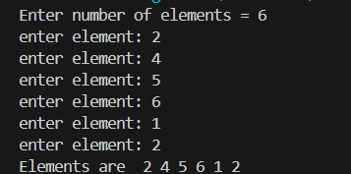

// 2. Sum & Average of Array**

// * Input marks of `n` students, find total & average.

#include<iostream>
using namespace std;

int main(){
int n, sum=0,count=0;
cout<<"Enter number of students : ";
cin>>n;
int arr[n];
for(int i=0;i<n;i++){
cout<<"enter marks = ";
cin>>arr[i];
count++;
}
for(int i=0;i<n;i++){
sum = sum + arr[i];
}
cout<<"sum of marks = "<<sum;
float average = sum/count;
cout<<"average = "<< average;

return 0;
}
Output
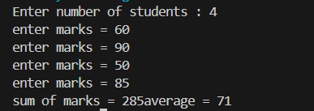
// 3. Find Maximum and Minimum**

// * Input array and print the largest & smallest element.

#include<iostream>
using namespace std;

int main(){
int n;
cout<<"Enter number of elements : ";
cin>>n;
int arr[n];
for(int i=0;i<n;i++){
cout<<"enter elements : ";
cin>>arr[i];
}
int min = arr[0];
int max = arr[0];
for(int i=0;i<n;i++){
if(arr[i]<min){
min=arr[i];
}
if(arr[i]> max){
max=arr[i];
}
}
cout<<"minimum : "<<min<<" maximum : "<<max;
return 0;
}
Output
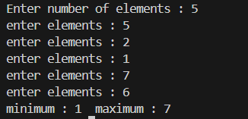

// 4. Search an Element (Linear Search)**

// * Input an array and search if a number exists.

#include<iostream>
using namespace std;

int main(){
int n, s;
cout<<"Enter number of element : ";
cin>>n;
int arr[n];
for(int i=0;i<n;i++){
cout<<"Enter element : ";
cin>>arr[i];
}
cout<<"Enter element to search : ";
cin>>s;
bool found = false;
for(int i=0;i<n;i++){
if(s == arr[i]){
cout<<"Element "<<s<<" found at position "<<(i+1);
found = true;
break;
}
}
if(!found){
cout<<"Element "<<s<<" not found";
}

return 0;
}

Output
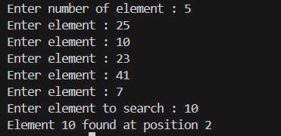

5. Reverse Array**

* Reverse an array and display the result.
#include<iostream>
using namespace std;

int main(){
int n;
cout << "Enter number of elements: ";
cin >> n;
int arr[n];
for(int i = 0; i < n; i++){
cout << "Enter element: ";
cin >> arr[i];
}
cout << "Original array: " << endl;
for(int i = 0; i < n; i++){
cout << arr[i] << " ";
}
cout << endl;

int temp[n];
for(int i = 0; i < n; i++){
temp[i] = arr[n - i - 1];
}

cout << "Reversed array: " << endl;
for(int i = 0; i < n; i++){
cout << temp[i] << " ";
}
cout << endl;

return 0;
}

Output
